Computers: Past, Present and Future
Introduction
Computer is an electronic programable machine that accepts data as input through input device then stores and processes it under the influence of a set of instruction called programs to produce the desired output generally referred to as information. Computers have become a part of our daily life, but they were not always small and fast like today. The journey of computers started almost two hundred years ago, and it is still going on. In this assignment I will explain how computers developed in the past, what they are like today, and what we can expect in the future.

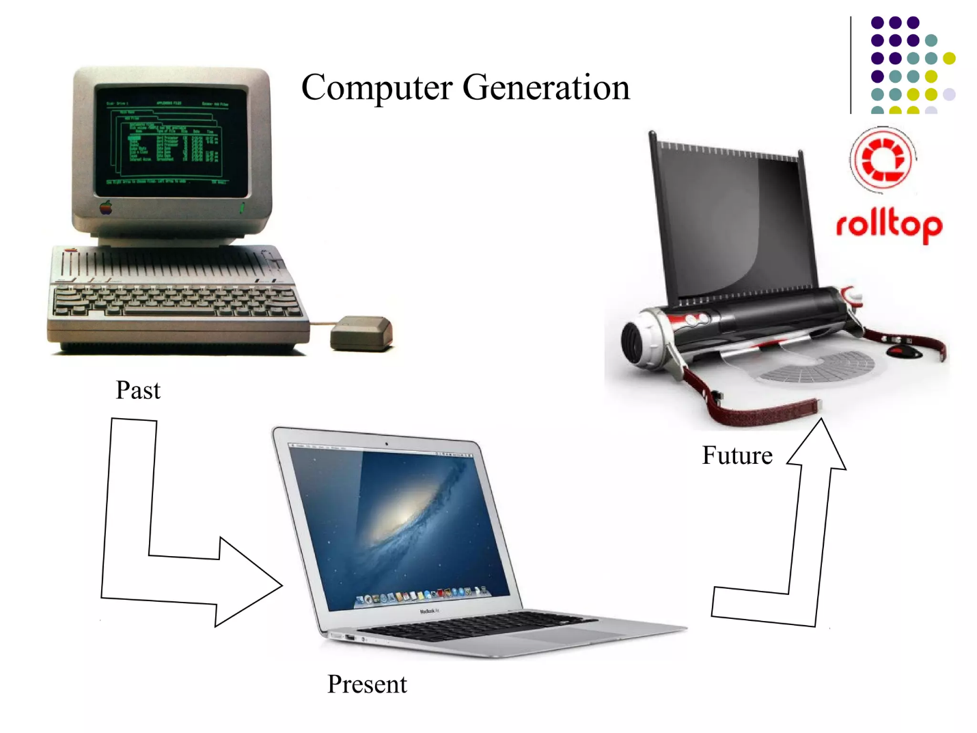

The Past
The idea of the computer started with Charles Babbage, who designed a machine called the Analytical Engine in the 1830s. Because of this work he is known as the father of the computer.
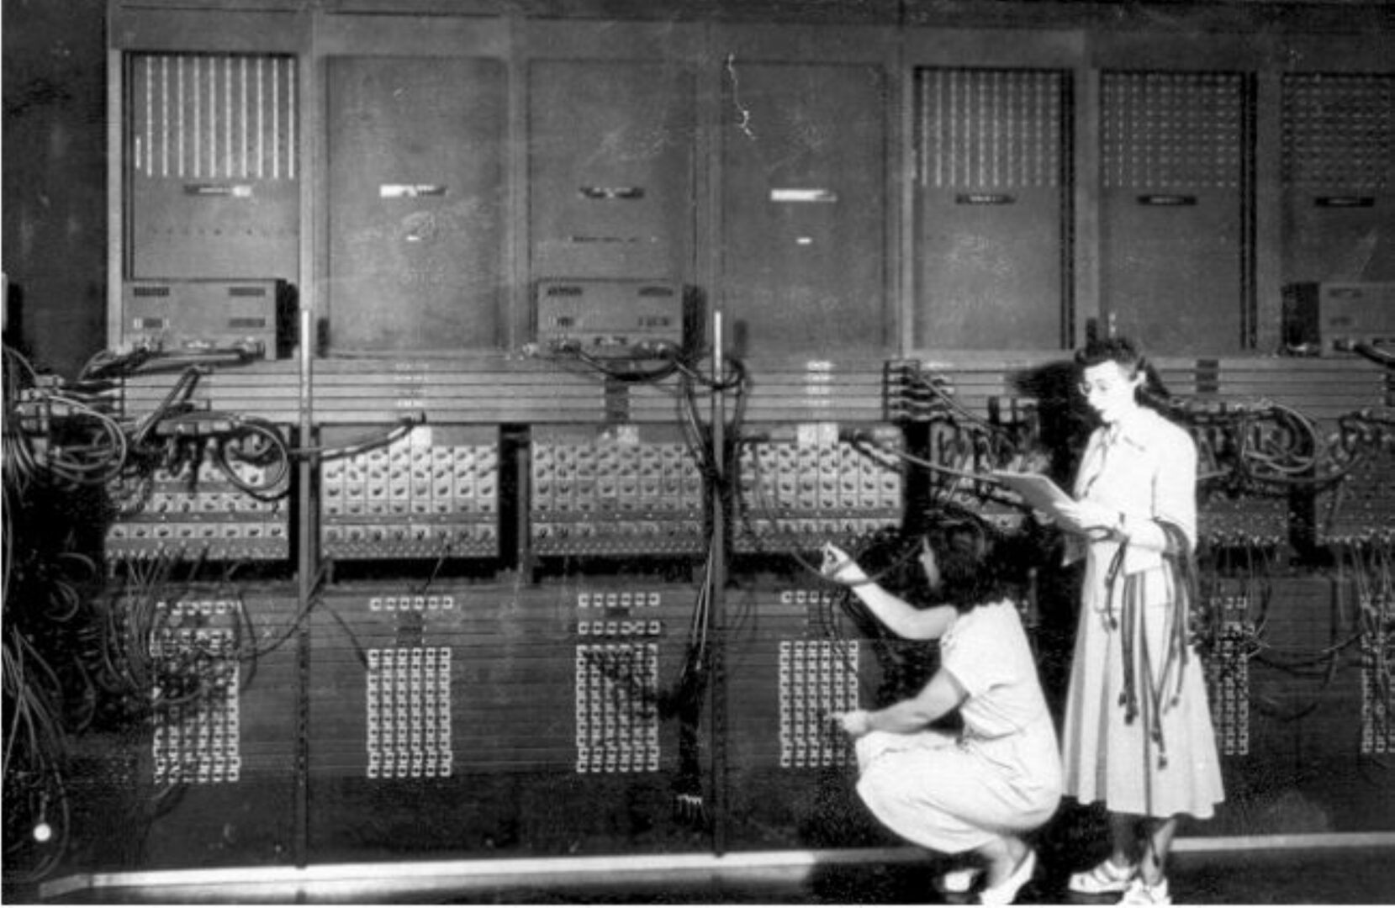
The first real electronic computer was ENIAC, UNIVAC, built in 1946. It was huge, about the size of a room, and used vacuum tubes. These early computers were very slow and expensive, and only governments and big companies could use them. They only understand machines language (binary 0s and 1s).
Over time computers became smaller and cheaper. Transistors replaced vacuum tubes, and then integrated circuits came in the 1960s. The biggest change came in 1971 when Intel made the first microprocessor, which put the whole brain of a computer on one small chip. In the late days, Apple and IBM companies started selling personal computers, so ordinary people could finally own one at home.

The Present
Today computers are everywhere. We use laptops, smartphones and tablets, and a modern phone is more powerful than the room-sized computers of the past. Most work is done on computers now, from writing documents to video calls. Almost every field today, like education, medicine, banking and entertainment, depends on computers. Computers have made our lives easier and more convenient. They help us study, communicate with people, store information, do calculations, prepare documents, and find information from the internet. With the development of modern technology, computers have become faster, smarter, and more powerful.
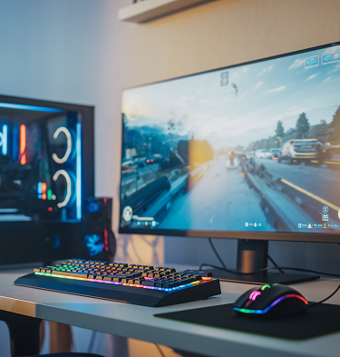

Some important technologies of the present are:
. Cloud computing – we can store files and run programs on the internet instead of on our devices.
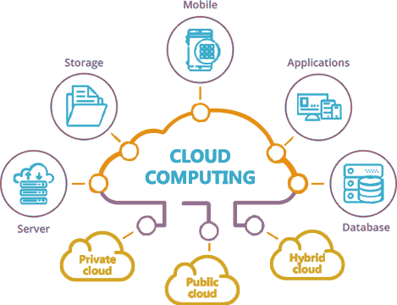
- Artificial Intelligence – computers can now learn from data, which is why apps can recommend videos, translate languages and answer questions.
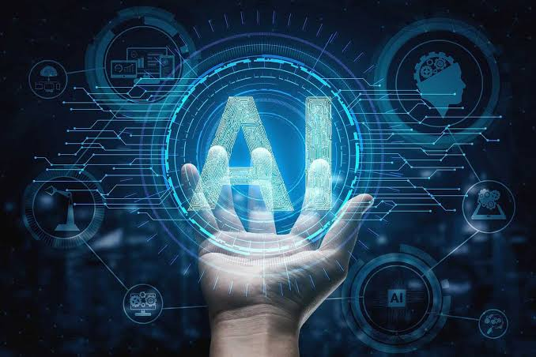
- Internet of Things – devices like watches, TVs and even refrigerators are connected to the internet.

The Future
In the future computers will become even smarter and more connected. Some expected developments are: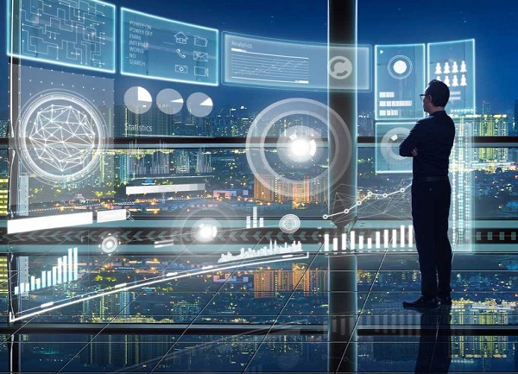
- More advanced AI that can think and reason more like humans.
- Quantum computing is becoming practical, which could solve problems that normal computers cannot handle.
- Brain-computer interfaces that could connect the human brain directly to machines.

- Green computing, meaning computers that use less energy and create less electronic waste.
Conclusion
Computers have changed from giant slow machines into small smart devices that almost everyone uses. The past shows us how far we have come; the present shows us how important computers have become, and the future shows us that even bigger changes are coming. Learning about this history helps us understand and prepare for the world of tomorrow.

